BUG AND TESTCASE MANAGEMENT SYSTEM

Abstract:

Bug and test case management system is an automated system that can be useful to employees and the managers in any functional organization. Bug Tracking System gives the facility to define the tasks in the organization and also allows the managers to track the bugs spent by the employee for that particular task. A report generation facility is supported in BTS that allows the managers to analyze which are those skills by employee are utilized and those which are not utilized. This tool can help managers for Bug estimation per project or application. This tool helps employees to document their Bugs and analyze This project aims at creation of a Bug Tracking System. This project will be accessible to all developers and its facility allows developers to focus on creating the database schema and while letting the application server define table based on the fields in app and relationships between them. This system provides the following facilities.

Introduction

Bug and testcase mechanism is employed only is some of the large software development houses. Most of the others never bothered with bug tracking at all, and instead simply relied on shared lists and email to monitor the status of defects. This procedure is error-prone and tends to cause those bugs judged least significant by developers to be dropped or ignored. Bug-Tracking System is an ideal solution to track the bugs of a product, solution or an application. Bug Tacking System allows individual or groups of developers to keep track of outstanding bugs in their product effectively. This can also be called as Defect Tracking System. The Bug Tracking System can dramatically increase the productivity and accountability of individual employees by providing a documented work flow and positive feedback for good performance.
This project is aimed at developing an online defect tracking system useful for applications developed in an organization. The Defect Tracking System (DTS) is a web based application that can be accessed throughout the organization. This system can be used for logging defects against an application/module, assigning defects to individuals and tracking the defects to resolution. There are features like email notifications, user maintenance, user access control, report generators etc in this system.

Literature Survey
Effective software development and quality assurance rely heavily on the ability to track bugs and manage test cases efficiently. Over the years, researchers and developers have recognized the importance of integrating bug tracking and test case management into the software development life cycle (SDLC). According to IEEE Software Engineering Journal, bug tracking systems significantly reduce the time and cost of fixing defects by providing centralized issue monitoring and resolution.
Tools like Bugzilla, JIRA, and TestLink are widely used in the industry for managing bugs and test cases. These platforms help development teams report issues, assign responsibilities, and track the progress of bug fixes and test executions. However, many of these systems are complex, require extensive training, or are not tailored to suit specific organizational workflows.
A study published in the ACM Computing Surveys highlights that the integration of bug tracking with test case management increases testing coverage and leads to more accurate release readiness assessments. Furthermore, research suggests that when QA teams can link test cases directly with detected bugs, it enhances traceability, reproducibility, and accountability in debugging and testing processes.
The proposed Bug and Test Case Management System addresses the limitations of traditional tools by offering a role-based access structure for Admins, Managers, Developers, Testers, and Analysts. Each role has dedicated functionality, such as test case creation and viewing (Tester), bug reporting and viewing (Tester/Developer), task assignment (Manager), and detailed report generation. The system supports real-time notifications, profile management, and role-specific dashboards to ensure that testing and debugging are streamlined and collaborative.
This literature insight supports the development of a comprehensive, customizable system that enhances software quality assurance and team productivity.

Existing System

The existing system consists of entering the details in the Microsoft Excel Sheets for the storing of the data. When a manager needs information of the employee he searches for the specified file in the file system. He opens the file and takes the information. Report Generation done manually by copying the content of the different files into another file. The Manually generated report was then printed.

Limitations in Existing System
- Information retrieval is a very big process.
- Lack of organization of the files may porn to information loss due to accidental deletion of files.
- No security because the files are visible to the users.
- Report generation will be a big task.

Proposed System

The Proposed system is a browser which is completely related to online system, which provides the centralized database. It stores bugs data and description of the particular bug data. It can also create Excel reports and PDF documents based on the information in its database.

Advantages

- The performance is increased due to well designed database.
- Security is increased
- Time saving in report generation
- Easy to update the details

Software Requirements
- Operating System : Windows
- User Interface : HTML, CSS , JS and Bootstrap
- Programming Language : Python
- Web Applications : Django
- IDE/Workbench : Pycharm
- Database : MYSQL, SQL, SQLYOG
- Server Deployment : Apache Tomcat

Hardware Requirements

- Processor : Intel I3 Processor
- RAM : 4 GB
- Monitor : 15 inch color monitor or LED
- Hard disk : 256 GB
- Key board : Standard 102 keys
- Mouse : Optical

Modules:

- Admin: This module has the entire access to all other modules, admin creates the project and assigning the projects to the created manager, adding members to the managers, assigning bugs based on the priority. Can update the manager, members and access to the particular project data. Generating reports based on the managers report submission

- Manager: Manager has the full access to the particular project assigned by the admin and controls the team members access to the bugs assigned. Has the permission to generate the reports and update the information of team members and adding members to the project.

- Developer: Can access the task or bug assigned by the manager, view assigned projects and resolving the assigned bug. Developer can view the bugs list assigned by the manager.

- Tester: Tester can access to the projects or bugs assigned by the manager, can view the assigned projects and can add a new bug to the list and send the bug back to the manager. Tester can login to the system and access the assigned projects list.

- Reports: Both Admin and Manager can access this module and generate the reports based on the requirements.

Functional Requirements:

Home
Notifications
Contact

Admin
Before Login
- Login
After Login
- Home
- Admin
- Change Passwords
- Logout
- Notifications
- Add Notifications
- View Notifications
- Employees
- Add Employees
- View Employees
- Views
- View Bugs
- View TestCases
- Reports
- Projects
- Add Projects
- View Projects
Employees
- Manager
Before Login
- Login
After Login
- Home
- Projects
- Tasks
- Add Tasks
- View Tasks
- Views
- View Bugs
- View TestCases
- Notifications
- Profile
- Update Profile
- Change Passwords
- Logout
- Developer
Before Login
- Login
After Login
- Home
- Projects
- Views
- View Bugs
- View TestCases
- Notifications
- Reports
- Profile
- Update Profile
- Change Passwords
- Logout

- Tester
Before Login
- Login
After Login
- Home
- Projects
- TestCases
- Add TestCases
- View TestCases
- Bugs
- Add Bugs
- View Bugs
- Reports
- Notifications
- Profile
- Update Profile
- Change Passwords
- Logout
- Analyst
Before Login
- Login
After Login
- Home
- Projects
- Requirements
- Views
- View Bugs
- View TestCaseas
- Reports
- Notifications
- Profile
- Update Profile
- Change Passwords
- Logout

Non Functional Requirements:
Non functional testing is a type of software testing that verifies non functional aspects of the product, such as performance, stability, and usability. Whereas functional testing verifies whether or not the product does what it is supposed to, non functional testing verifies how well the product performs.
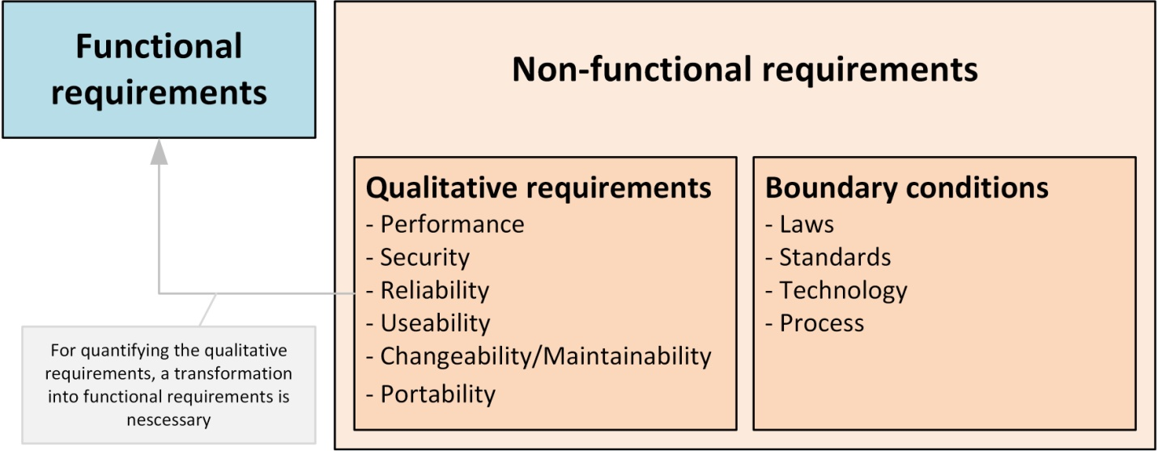

The system should shows below non functional requirements
- High Security
- Multi browser and operating system compatibility
- Mobile responsiveness
- High quality and performance
- Memory optimized and User Friendliness
- Easy maintenance and scalable capability
- It's should support good accessibility and usability
- It should follow regulatory and compliance policies

Feasibility Study:
The possibility of the undertaking is broke down during this stage and strategic plan is advanced with an exceptionally broad arrangement for the task and a few quotes. During project examination the likelihood investigation of the proposed project is to be completed. this is often to ensure that the proposed project isn't a weight to the organization. For practicality examination, some comprehension of the many necessities for the project is prime.
After the approval of the request to the organization and project guide, with an investigation being considered, the project request must be examined to determine precisely what the system requires.
Not all request projects are desirable or feasible. Some organization receives so many project requests from client users that only few of them are pursued. However, those projects that are both feasible and desirable should be put into schedule. After a project request is approved, it cost, priority, completion time and personnel requirement is estimated and used to determine where to add it to any project list. Truly speaking, the approval of those above factors, development works can be launched
An important outcome of preliminary investigation is the determination that the system request is feasible. This is possible only if it is feasible within limited resource and time. The different feasibilities that have to be analyzed are.

ECONOMICAL FEASIBILITY
This examination is completed to see the financial effect that the framework will wear the association. The measure of store that the organization can fill the innovative work of the framework is constrained. The consumptions must be advocated. Accordingly, the created framework also inside the budget and this was accomplished in light of the very fact that an outsized portion of the advancements utilized are uninhibitedly accessible. Just the modified items must be bought. Economic Feasibility or Cost-benefit is an assessment of the economic justification for a computer based project. As hardware was installed from the beginning & for lots of purposes thus the cost on project of hardware is low. And also in this project work all software is free and open source. It can be developed using our personal machines. So its economically its feasible to complete the project.
TECHNICAL FEASIBILITY
According to Roger S. Pressman, Technical Feasibility is the assessment of the technical resources of the organization. The system is developed for platform Independent environment. The technical feasibility has been carried out. The system is technically feasible for development and can be developed with the existing facility.
This investigation is completed to see the technical practicality, that is, the specialized prerequisites of the framework. Any framework created must not have a popularity on the accessible specialized assets. this may prompt high requests on the accessible specialized assets. this may prompt high requests being assail the customer. The created framework must have a humble prerequisite, as just insignificant or invalid changes are required for actualizing this framework.
SOCIAL FEASIBILITY
The a part of study is to see the degree of acknowledgment of the framework by the client. This incorporates the way toward preparing the client to utilize the framework effectively. The client must not feel undermined by the framework, rather should acknowledge it as a requirement . The degree of acknowledgment by the clients exclusively relies upon the techniques that are utilized to show the client about the framework and to form him familiar with it. His degree of certainty must be raised with the goal that he's likewise able to make some helpful analysis, which is invited, as he's the last client of the framework.
OPERATIONAL FEASIBILITY
This region of attainability ensures that the undertaking fulfills all the prerequisites that were talks about during introductory necessity examination stage. This undertaking met all the necessities proposed before. It ensured that the modules examined during the proposing of the framework were actualized with stable precision and with no mistakes.
Operational Feasibility deals with the study of prospects of the system to be developed. This system operationally eliminates all the tensions of the Admin and helps him in effectively tracking the project progress. This kind of automation will surely reduce the time and energy, which previously consumed in manual work. Based on the study, the system is proved to be operationally feasible.

Process Models
1. Waterfall Model:
Waterfall model indicates that all the SDLC steps will be going on step by step. In this model once one stage completed then only it will start the another process. This will be implemented when the requirements well known and clearly defined.
In this model we can implement all the steps one by one. First we will do requirements gathering i.e in this step business analyst will collect the all functional requirements from the client and will discuss with the manager and development team. Second step is analysis where people can analyses the requirements so that they will do risk basement, risk mitigation, risk controlling steps. And also they will do the cost-time analysis to estimate the cost. They will also do the detail feasible study over the requirements of project.
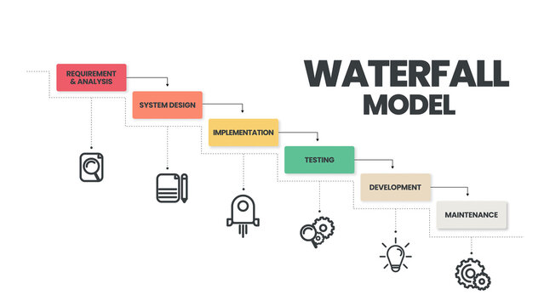
In third phase called design page generally people will design the project i.e architect will prepare the UML diagrams and prototypes for project. And then developers will start programming or coding based on design . Finally testing team will test the content to identify and fix the bugs. After successful user acceptance testing application will be deployed and maintained in the client machine.
The waterfall model was selected as the SDLC model due to the following reasons:
- When the requirements are very clear and not changed.
- Available technology is enough to implement.
- Project is easy and simple to understand to finish.
- And if we don’t have any confusion in requirements.
- We can easily manage the review process and task management.
- Every stage defined clearly and with timelines

2. Agile Scrum Model:
Agile scrum methodology is the combination of the agile philosophy and the scrum framework. Agile means “incremental, allowing teams to develop projects in small increments. Scrum is one of the many types of agile methodology, known for breaking projects down into sizable chunks called “sprints.” Agile scrum methodology is good for businesses that need to finish specific projects quickly.
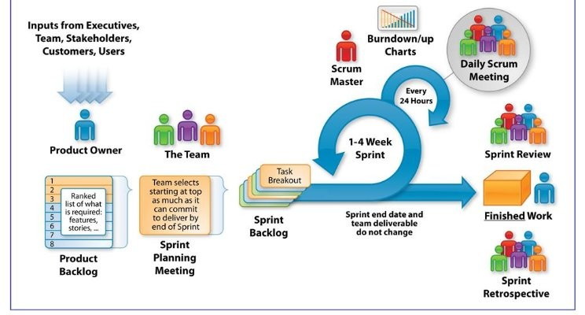
Agile scrum methodology is a project management system that relies on incremental development. Each iteration consists of two- to four-week sprints, where the goal of each sprint is to build the most important features first and come out with a potentially deliverable product. More features are built into the product in subsequent sprints and are adjusted based on stakeholder and customer feedback between sprints. Whereas other project management methods emphasize building an entire product in one operation from start to finish, agile scrum methodology focuses on delivering several iterations of a product to provide stakeholders with the highest business value in the least amount of time.
Agile scrum methodology has several benefits. First, it encourages products to be built faster, since each set of goals must be completed within each sprint’s time frame. It also requires frequent planning and goal setting, which helps the scrum team focus on the current sprint’s objectives and increase productivity.
The greatest benefit of agile scrum methodology is its flexibility. With the sprint-based model, the scrum team typically receives feedback from stakeholders after each sprint. If there are any problems or changes, the scrum team can easily and quickly adjust product goals during future sprints to provide more valuable iterations. This way, stakeholders are happier because they get exactly what they want after being involved every step of the way.

Client Server Architecture
Client server architecture, architecture of a computer network in which many clients (remote processors) request and receive service from a centralized server (host computer). Client computers provide an interface to allow a computer user to request services of the server and to display the results the server returns.
The Client-server model is a distributed application structure that partitions tasks or workloads between the providers of a resource or service, called servers, and service requesters called clients. In the client-server architecture, when the client computer sends a request for data to the server through the internet, the server accepts the requested process and delivers the data packets requested back to the client. Clients do not share any of their resources. Examples of the Client-Server Model are Email, World Wide Web, etc.
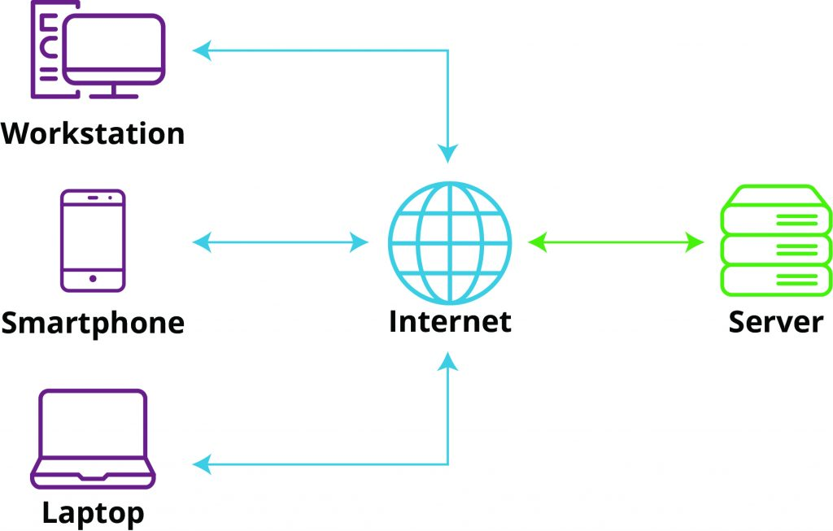

Web Application MVC Architecture
The Model-View-Controller (MVC) is a well-known design pattern in the web development field. It is way to organize our code. It specifies that a program or application shall consist of data model, presentation information and control information. The MVC pattern needs all these components to be separated as different objects.
The MVC pattern architecture consists of three layers:
- Model: It represents the business layer of application. It is an object to carry the data that can also contain the logic to update controller if data is changed.
- View: It represents the presentation layer of application. It is used to visualize the data that the model contains.
- Controller: It works on both the model and view. It is used to manage the flow of application, i.e. data flow in the model object and to update the view whenever data is changed.

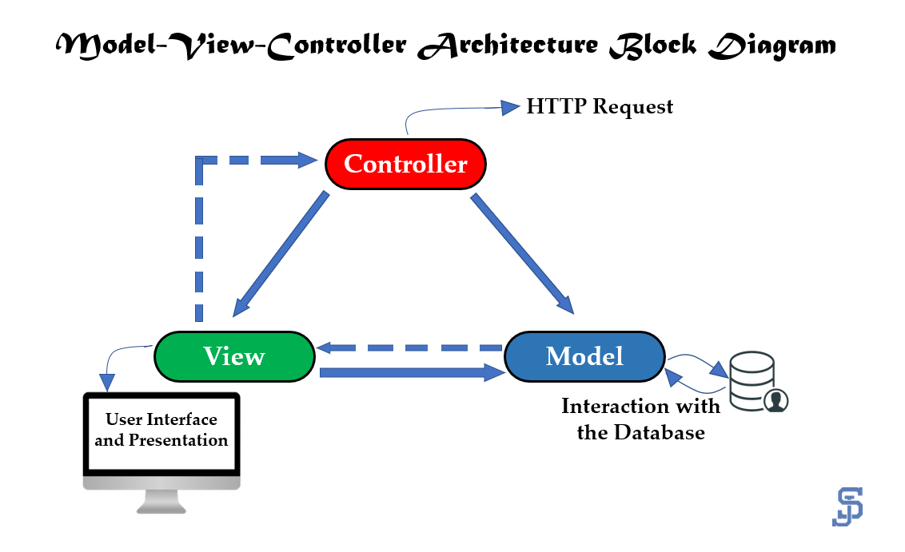

Web Application MVT Architecture
The MVT (Model View Template) is a software design pattern. It is a collection of three important components Model View and Template. The Model helps to handle database. It is a data access layer which handles the data.
The Template is a presentation layer which handles User Interface part completely. The View is used to execute the business logic and interact with a model to carry data and renders a template.
The model is going to act as the interface of your data. It is responsible for maintaining data. It is the logical data structure behind the entire application and is represented by a database (generally relational databases such as MySql, Postgres).
The View is the user interface — what you see in your browser when you render a website. It is represented by HTML/CSS/Javascript and Jinja files.

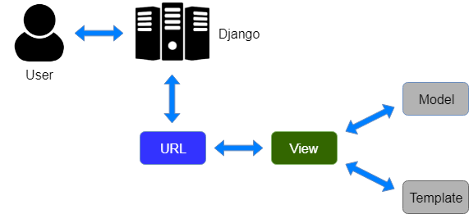

Conclusion

The Bug and Test Case Management System is designed to streamline and enhance the software development and quality assurance processes by offering a centralized platform for managing bugs, test cases, tasks, and team roles. By incorporating structured workflows and real-time notifications for Admins, Managers, Developers, Testers, and Analysts, the system ensures seamless collaboration and efficient tracking of issues throughout the project lifecycle.
The platform improves traceability, accountability, and resolution speed by allowing test cases and bugs to be systematically logged, assigned, and reviewed. Additionally, the system promotes transparency and better communication among teams, thereby improving the overall quality and reliability of software products.
In conclusion, this system not only automates the tedious aspects of bug tracking and test case handling but also provides valuable insights through reports and analytics, contributing significantly to project success and customer satisfaction.

